- SW103 mod
  - I messed up the push button footprint.
  - Without this mod the reset get permanently held low
  - Steps:
    - Cut the red trace
    - Lift the GREEN leg of the switch (or clip it)
    - Rotate the pink resistor like indicated (new position is R22-2 to R20-1)
  - 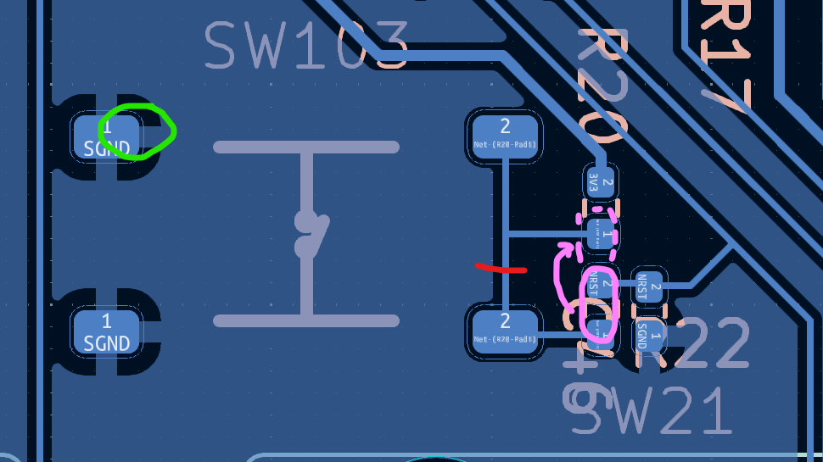
- SW104 mod
  - BTN1 to the MCU permanently held low unless this mod is applied
  - Steps:
    - Cut at the RED
    - Lift the GREEN leg of the switch (or clip it)
    - Rotate the pink resistor like indicated (new position is R27-2 to R25-1)
  - 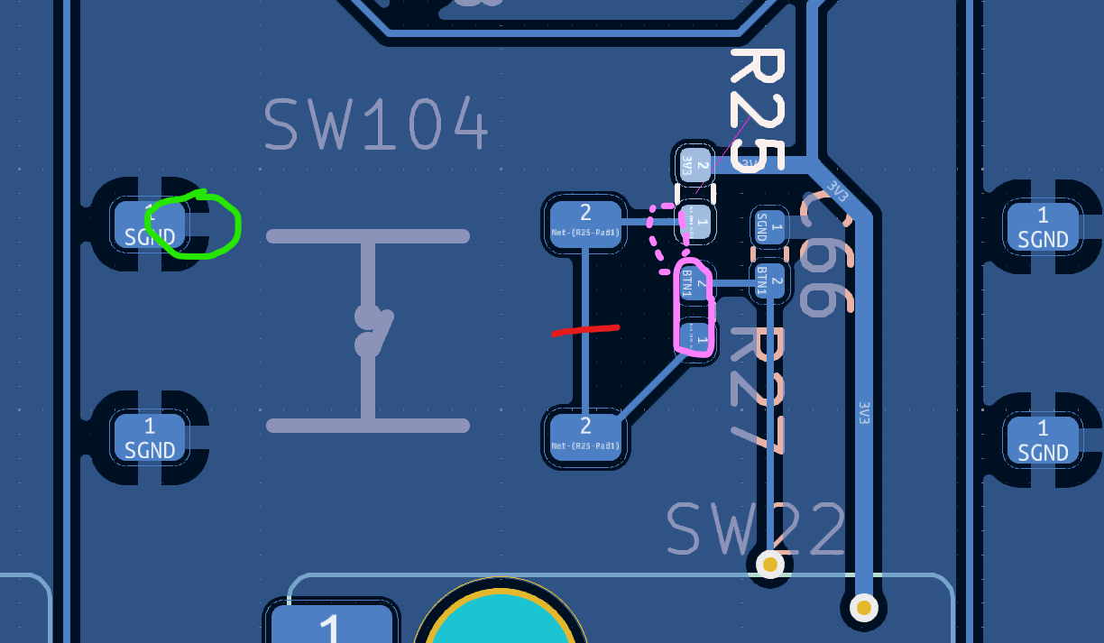
- Move RGB_DATA_3V3 to SPI3 MOSI pin PC12, pin 80 on the MCU. Cut and jump.
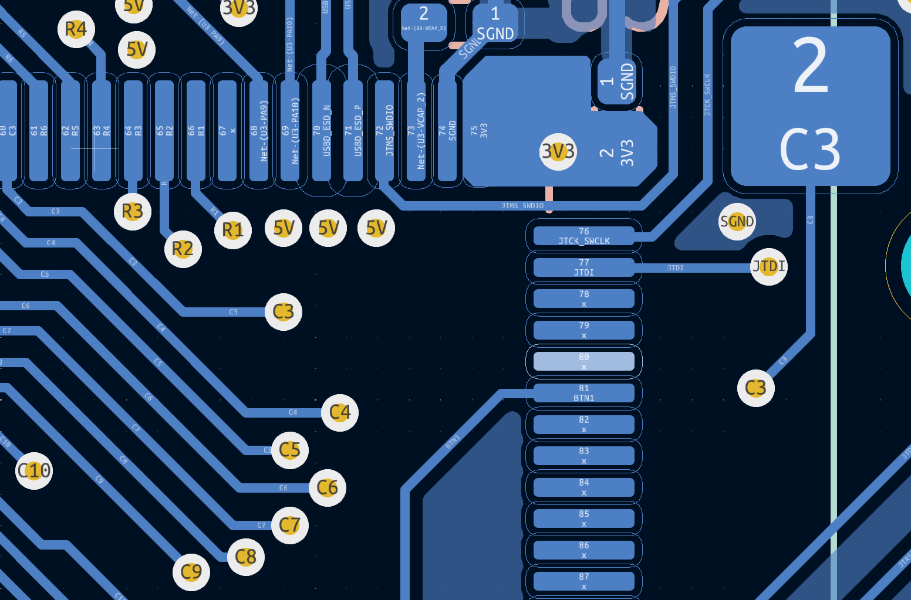
Pin 80

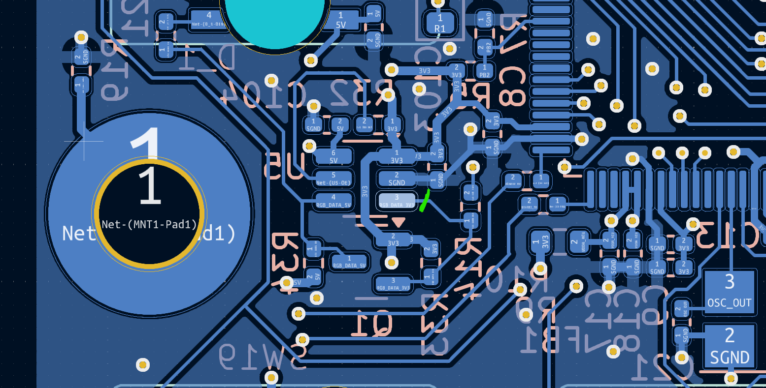
U5-3 (input)

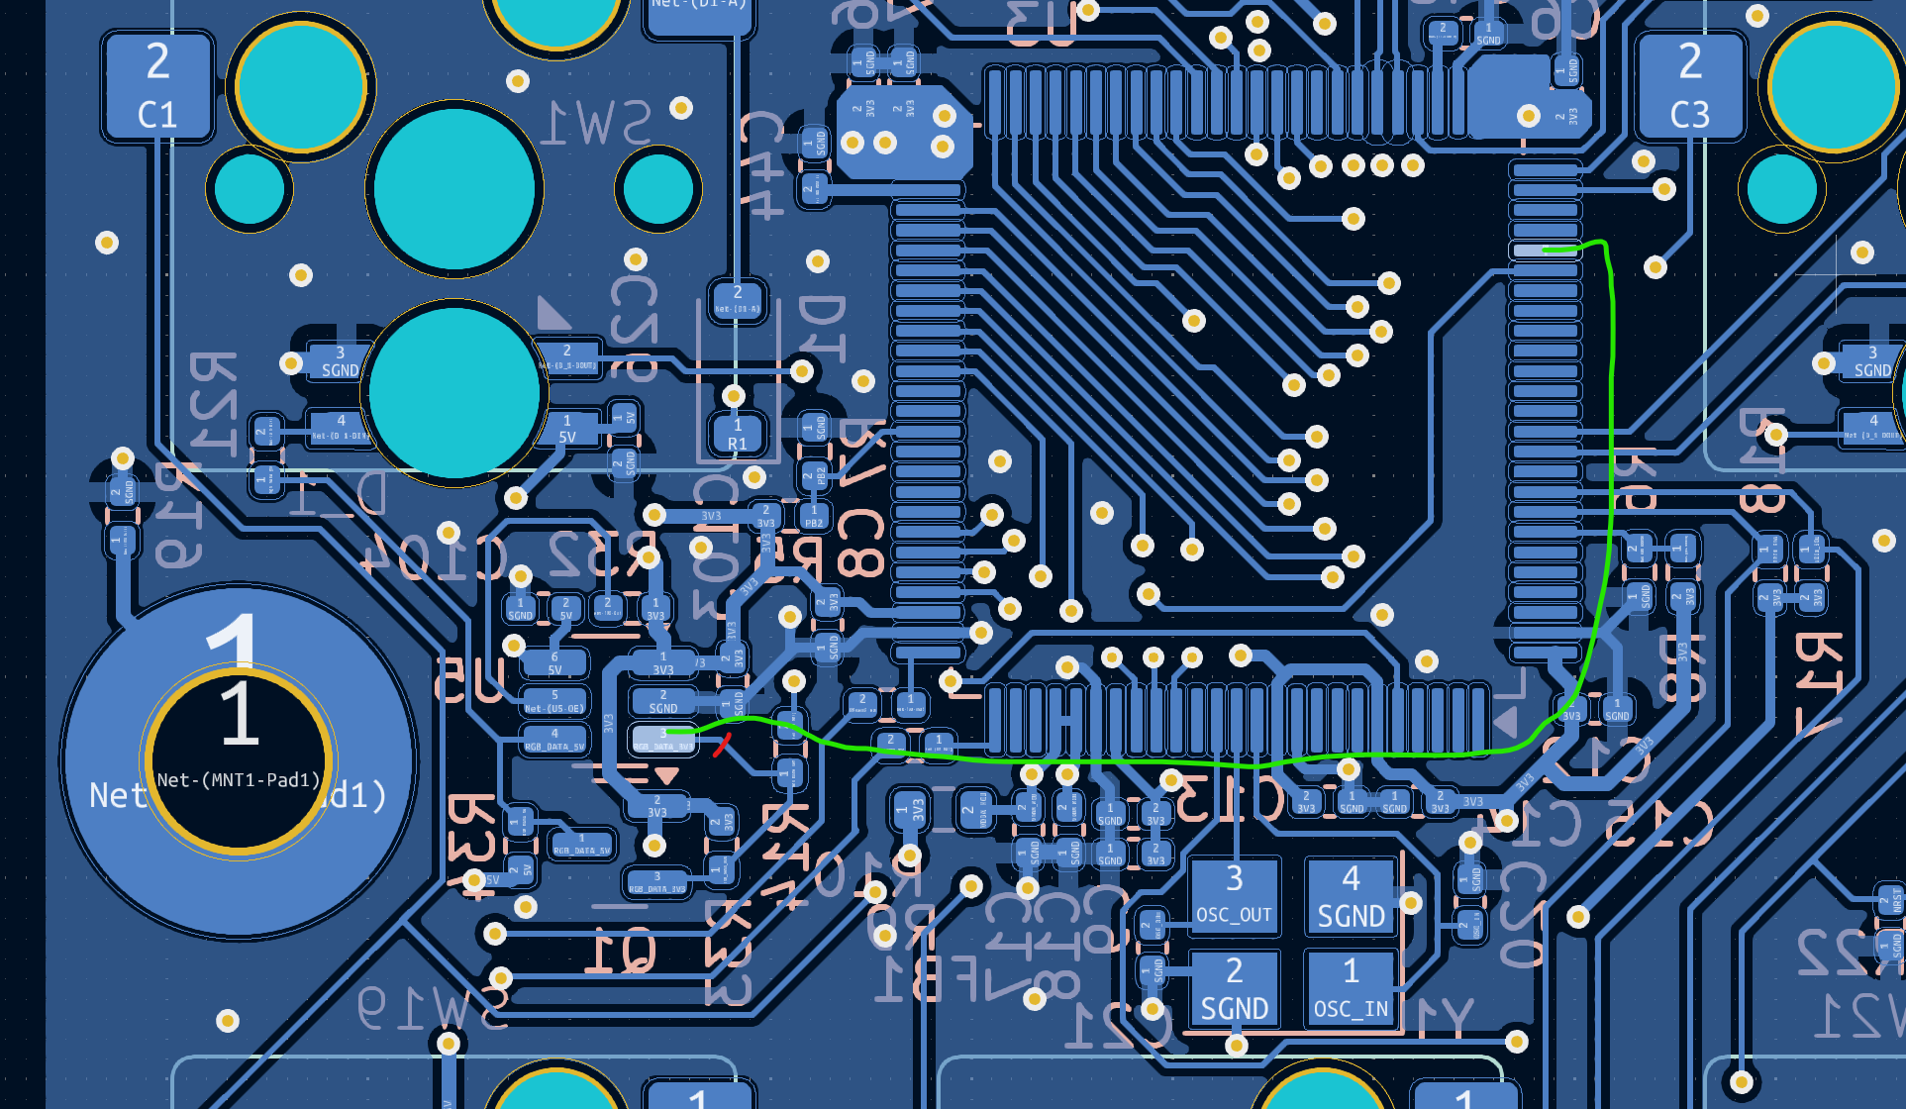

- 1K Pull down on RGB_DATA_3V3
  - Add a 1K resistor (0402) from U5-3 to U5-2
  - 